Launch Settings.json(s.Mangayarkarasi)

1. It's present in properties

2. it has two profiles with commandName: IISExpress and commanName: Project

3. if you Debug ur app with selecting IISExpress then it will run in port specified by it

i.e application URL: mentioned in it or

if we select Project it will run in that port specified by it in launchsettings .json

i.e application URL: mentioned in it

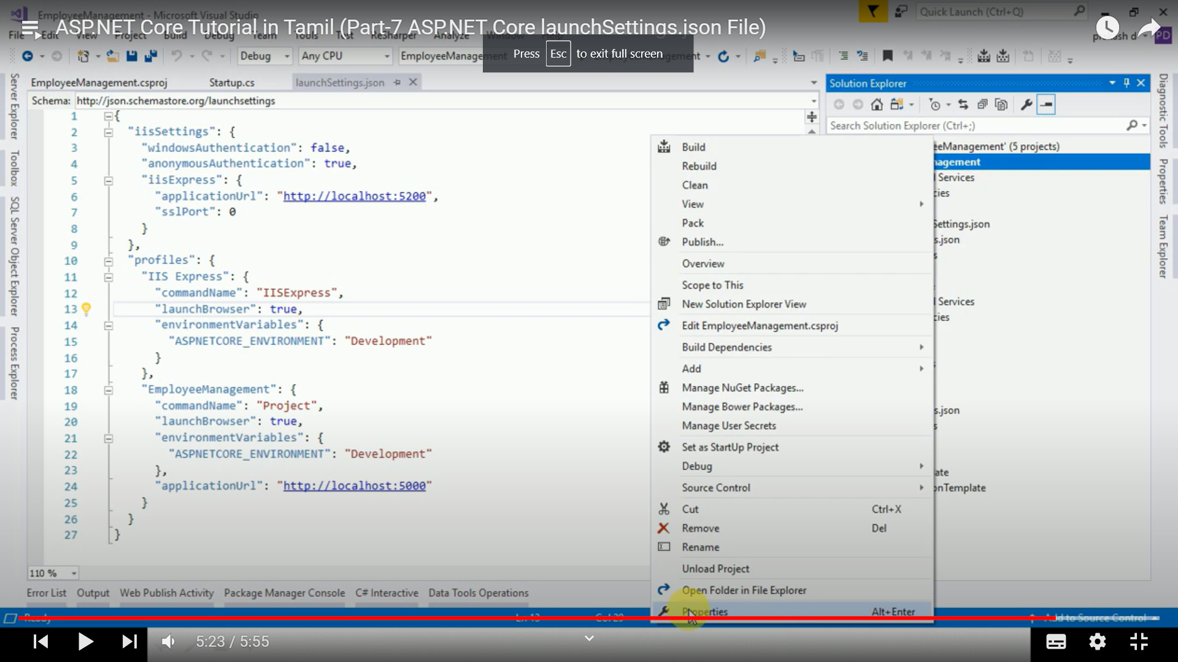

4. it will use IIS or IISExpress as server if profile is IISExpress

or

it will use kestrel if profile is project.

